+AWS responsibility shared model:
- Customers are responsible for the security of everything that they create and put in the AWS Cloud.
- AWS is responsible for security of the cloud.
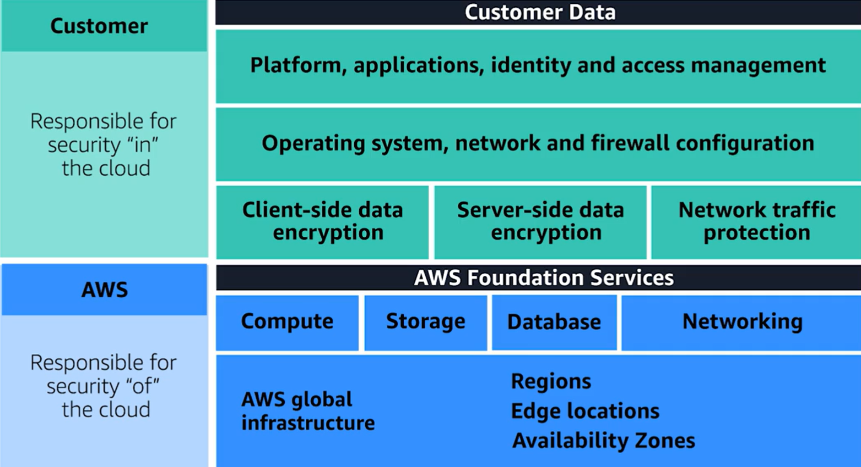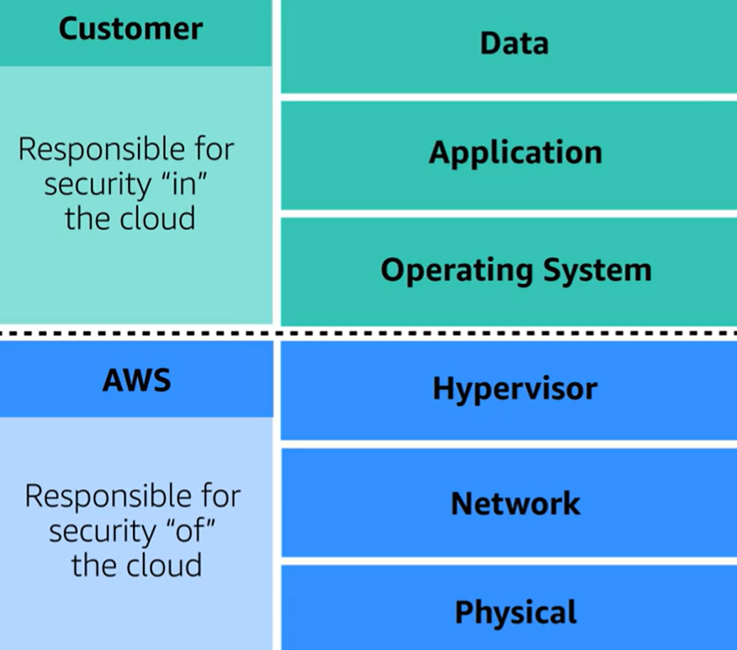
+IAM
- On creation root user (turn on NFA)
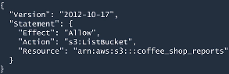
- add users/groups (can do nthng by dflt) - Use Principle of Least Privilige: Granting only the permissions that are needed to perform specific tasks(role 4 spcfc
tasks)
- IAM Policy: Json file with API calls allowed/not allowed for users/grps
- Role: temporary permissions overruling other permissions for the time, given to users, or services (EC2 has a role allowing access to S3)
- AWS Organizations: manage all accounts/OUs, SCP Service Control Policy :access permissions for account/Ous (~users/grps)
+DDOS Distributed Denial Of Service: mltpl hacked machines overwhelm Service
- UDP flood: attckr asks a srv for data and sets vctm’s service as response destination
- HTTP level attack
- Slow Horse Attack: Zombie customer pretends having bad connection
+ELB & AWS Size makes it hard to do so
AWS Security Services:
+AWS WAF: ML deffendor
+AWS Shield
+AWS Key Management Service: Protects Data at rest
+Amazon Cloud Watch: Monitor ressources All using metrics, Cloudwatch alarm->SNS
+Amazon Cloud Trail : API Auditing Tool, Logs everything
+Amazon Trusted Advisor: Checks and advises on Pillars like security prblms, under/over use resrcs
+AWS Instance Metadata Service:
-Gives Metadata(ID, Creds…) about instance through internal IP:169.254.169.254
Connect to instance through ssh: ssh -i ~/keys/my-key.pem ec2-user@54.123.45.67
Access metadata: curl 169.254.169.254/latest/meta-data/
-(SSRF) vulnerabilities in applications that are hosted on these instances !

Accessing the AWS CLI
Through it, we can make API Calls to all AWS services
Used when: Stolen Cridentials aren’t for console (for automated tasks)

└─$aws [options] <command> <subcommand> [parameters] Commands
--no-verify-ssl
--output json…
add if u have multiple creds for each profile, so cmnds require --profile flag to use his creds and not the dflt (w/ flag))

└─$aws configure {--profile profilename}

AWS Access Key ID [None]: AKIA...
IAM user specific identify User Account
AWS Secret Access Key [None]: ...
Default region name [None]: us-east-1 {specific for instance}
Default output format [None]: json

└─$ aws sts get-caller-identity (access-undeniable) <==> └─$ whoami

+Access instance through SSH

+Roles give temporary AccessKeyId, SecretAccessKey, SessionToken

+ARN (Amazon Resource Name) is a unique identifier for AWS resources
└─$ aws iam list-roles --query "Roles[?RoleName=='AWSCLIRole']"
>>AssumeRolePolicyDocument which is what tells AWS who the role trusts to assume it
>>”Arn”: “arn:aws:iam::272281913033:role/AWSCLIRole” >>That’s the role ARN = roleID

+Assume role:
- Add it as a profile in ~/.aws/config :
- [profile NameOfRole]
role_arn = arn:aws:iam::1122334455:role/NameOfRole
source_profile = default/profile_name
- aws cmmnd --profile NameOfRole

└─$ aws s3api list-buckets --profile cybrcli >>list buckets

Enumeration Commands
User&Group Enumeration:
└─$ aws iam get-user #~whoamai, but requires perms
└─$ aws iam list-users
└─$ aws iam list-access-keys
└─$ aws iam get-account-authorization-details

└─$ aws iam list-user-policies --user-name name_of_user :in-Line policies: directly attached to usr/grp/role

└─$ aws iam list-attached-user-policies --user-name name_of_user :managed policies: templates by aws/users attrbtd
└─$ aws iam get-user-policy --user-name name_of_user –policy-name name_of_policy

└─$ aws iam list-groups
└─$ aws iam list-groups-for-user --user-name name_of_user
└─$ aws iam get-group --group-name name_of_group
└─$ aws iam list-group-policies --group-name name_of_group
└─$ aws iam list-attached-group-policies --group-name name_of_group
└─$ aws iam get-group-policy –policy-name name_of_policy

IAM Role Enumeration:
└─$ aws iam list-roles {--query "Roles[?RoleName=='SupportRole']"} =>AssumeRolPolicyDocument: who can assune it
└─$ aws iam list-role-policies –role-name name_of_role
=>AssumeRolPolicyDocument: who can assume it
└─$ aws iam get-role-policy –-role-name name_of_role –policy-name name_of_policy

nmap
Nslookup x2, whois…
Try accessing metadata file IAM roles & and their creds access as that role & check perms
AWS Account ID:
-from S3 buckets:

Security Practices
+Isolate a ressource (EC2, S2..) after a sec incident/having indicators of compromise, or IOCs
- Modify security groups
- Adjust network ACLs
- Update route tables
- Use IAM policies
- Change S3 bucket policies
- Remove load balancers
- Detach from Auto Scaling Groups

+Preserving Forensic Evidence
- Use a separate forensic AWS account.
- Process:
  - An incident triggers an SNS topic.
  - The topic calls a Lambda function.
  - Lambda collects a memory dump and stores it in a forensic S3 bucket.
  - A forensic AMI (image) is created using EC2 Image Builder for analysis later.
- Protect forensic data using:
  - S3 Object Lock (prevents deletion or overwriteS3 Object Lock for a fixed amount of time or indefinitely)
  - Lifecycle rules (manage storage automatically)
  - S3 replication (for backup)

